  

**The President and Members of**

**ROTARY CLUB OF ADYAR**

cordially invite you with your spouse for the Installation of

**Rtn. N R.Jayaraman**

as the President and

the members of the Board for the year 2015-16

on**Tuesday the 14th July 2015 at 6.15 p.m.**

at

**Hotel Savera, Dr.RadhakrishnanSalai,**

**Mylapore, Chennai-600 004.**

**Rtn. C.R.RAJU**

**Dist. Governor, R.I. Dist. 3230**

has kindly consented to be the Chief Guest

Meeting Called to Order – 6.45 P.M.

Dinner - 8.30 P.M.

**Rtn. J.Jayaseelan Rtn. M.E.Boopathiraja** **Rtn. T.Sathish**

President Director - Club Service Secretary

**ROTARY CLUB OF ADYAR**

**31ST INSTALLATION CEREMONY ON 14TH JULY 2015**

**An EVENT REPORT**

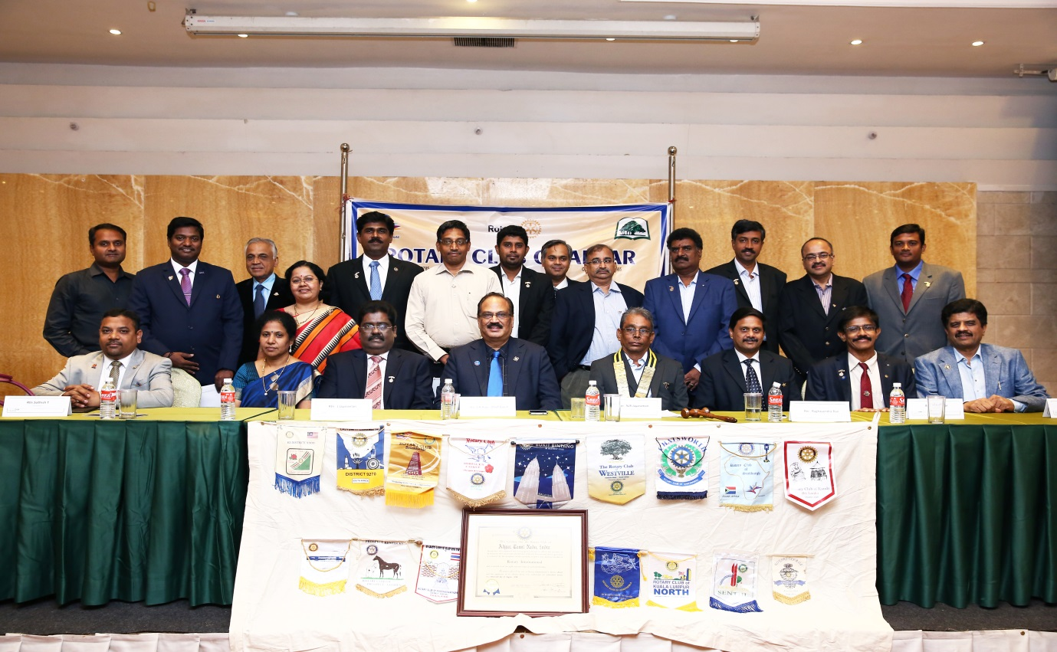

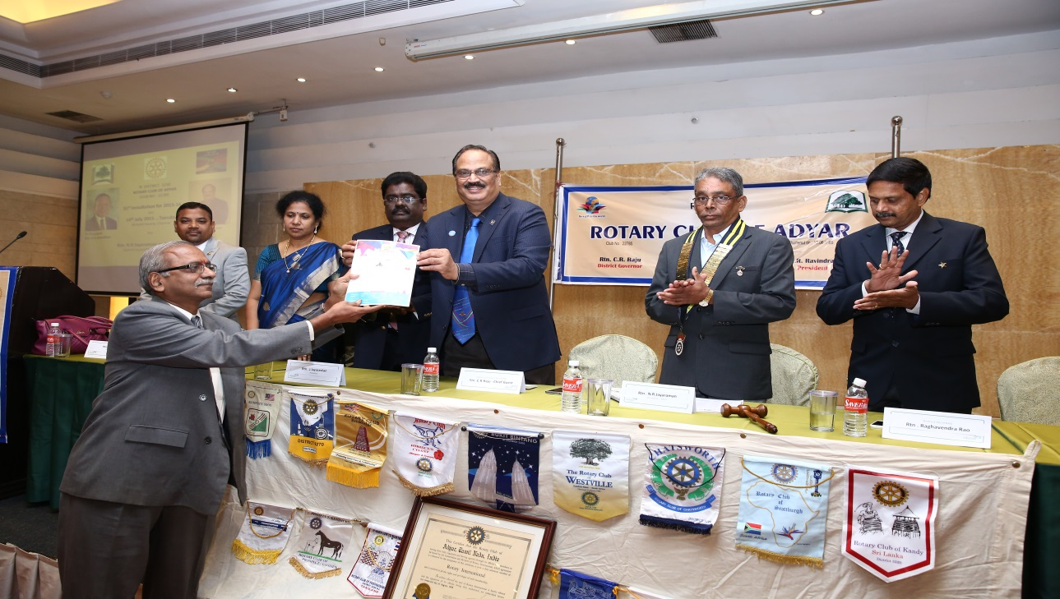

**RC ADYAR’S 31ST INSTALLATION CEREMONY ON 14TH JULY 2015**

**EVENT REPORT FROM THE DESK OF SECRETARY**

|  |  |  |  |
| --- | --- | --- | --- |
| **No** | **Name of the event** | **Details of the Event** | **Remarks** |
| **1** | **Welcome speech** | **Given by President ( 2014-15) Rtn.J.Jayaseelan who thanked his team for the excellent support during all the events of the year 2014-15 .** | **Great start** |
| **2** | **Secretary’s Annual Report** | **A Very comprehensive and detailed report was presented through a PPT ( of size : 500 MB) and the events were recorded MONTH WISE , DOMAIN WISE , EVENT WISE with pictures and statistics and the presentation gave a bird’s eye view on the volume of service and work done by the Club during the year , which has actually set up a trend for others to follow .** | **The chief Guest DG Rtn.C.R.Raju was amazed by the detailing and appreciated in his Speech .** |
| **3** | **Introduction of Incoming President Rtn.Jayaraman by Rtn.Thiagu** | **A compact and lucid introduction which touched upon the Personal , professional accomplishments of Rtn.Jayaraman and his commitment to Cause .** | **Short and sweet** |
| **4** | **Installation of NEW President for the year by out going President Rtn.Jayaseelan & other formalities** | **Done with cheer and vigor ..................**   * **The Collaring was the key element of handing over with best wishes .** * **Lapel pinning was done by both Presidents to each other .** * **Incoming President gave the Acceptance speech which was designed aptly as quoted by the Chief guest ( the Planning for the year was well enumerated )** * **President Rtn.Jayaraman introduced his team of Office bearers whose Photos and Classification details were presented parallelly through a PPT.** * **Out going secretary RtnSatish handed over the CLUB CHARTER ( Framed ) to the incoming Secretary Rtn . Eashwer and it was gracefully accepted with respect and regard.** * **Chief Guest DG Rtn . C.R. Raju & Dist Secretary Rtn. Raghavendra Rao were requested to Pin the entire Board members of the new team which was done perfectly.** | **There was mutual respect and cheer among the Presidents.**  **He thanked the outgoing team for its bench mark achievements .**  **The PPT is attached with this report.**  **Guests wished the entire team of office bearers for an excellent Rotary year ahead.** |

|  |  |  |  |
| --- | --- | --- | --- |
| **5** |  | * **Club Bulleting BANYAN TREE was released by the Chief guest and the copies were shared among the participants .** * **The EOI – EXPRESSION OF INTEREST AND STATUS REPORT on the Kandigai school for the SANGAMITRA PROJECT was shared with DG , DISTRICT SECRETARY , Dist Officials Rtn . Mohanaraghavan & Rtn.Muthupalaniappan** * **Rotary Foundation announcements were made by Rtn . Subash who is the Director for International Relations . He informed the collection of US $ 8000.00 for RI along with other donations and committments .** * **Special announcement : Special Club Endownment fund given by RtnJ.Jayaseelan ( Rs 500000) for service on Education was recorded and applauded by one and all .** * **Doctor BALA ( Late Ex member of RCA )AWARD was given to FOUR STUDENTS for excellent achievements.** | **The Bulletin was awarded for its design and details last year.**  **President appreciated the timing of the report and promised funding from the district.**  **This was specially appreciated by the Chief Guest**  **This gesture by Rtn.Jayaseelan was besides his contribution for RI endowment fund which was appreciated by one and all.** |
| **6** | **Introduction of Chief Guest** | **This was done crisply as He is a well known Rotarian across the globe .** |  |
| **7** | **Guest Lecture by DG Rtn .C.R.Raju** | **He covered all the aspects of Rotary in his own inimical style with great involvment and detailing .**   1. **He thanked and appreciated the out going President Rtn.J.Jayaseelan for his EXCELLENT LEADERSHIP DISPLAYED with humility throughout the year which has made bench mark achievements in all the spheres of Rotary as far as Club activities are concerned .** 2. **He appreciated the incoming President for his acceptance speech which reflected meticulous planning and committment .** 3. **He appreciated out going secretary Rtn .Satish T for the excellent annual report which itself is a great task of compilation and design .** 4. **He specifically pointed out the interesting activities of RC Adyar such as CONDUCTING BOARD OF DIRECTORS MEETING every month that too in Rotarians homes which would exhibit and bring in closer bonding among families .** 5. **He recognized the potential members who have attended the ceremony ( Four of them ) and pointed out that such Youngsters are the real need of Rotary to day.** 6. **He recognised PDG SHYAM SUNDAR who is from RC Adyar who played a major role in the upbringing of RC Adyar .** 7. **He recollected the service of Rtn.Veeramani ( Club Advisor )whose contribution to both RCA and RI are significant.** 8. **He recollected his visit to NALLAMBAKKKAM school few months back for the TOILET opening project and sited the good gesture of RCA to take the suggestions for improvements in the right spirit and get them implemented in the next set of Toilets , to be released this month ( as mentioned in the Secretary’s report )** 9. **He cited the contribution of senior Rtn.Narasimha Iyengar for the Club and his association with him in Rotary.** 10. **He remarked RC ADYAR as one of the top clubs of the District and requested RCA to support newly started clubs which are struggling in many ways from membership – attendance to Fund raising.** 11. **He committed on the RI support in his tenure for EACH ROTARY CLUB and asked clubs to e connect with RI for various support measures. He asked every Rotarian to use ROW which has a MOBILE APP .** | **His speech radiated his happiness coupled with a sense of satisfaction on RCA‘s achievements .**  **He also hoped that this trend will continue and many more Mile stones will be reached .**  **He cited the growth of ANNETTES CLUB and INNERWHEEL CLUB in the last year and asked them to enhance their participation more in the coming years** |
| **8** | **Secretary’s announcements and Vote of Thanks** | * **Secretary Rtn .C.Eashwer announced the Birth days and Wedding anniversaries .**   **Birthdays wishes for HARIKRISHNA BHARATH son of RtnKulamani , ANANYA RAJAN daughter of RtnVittalRajan , Charanya Daughter of Rtn KRISHNAN , Arvind Son of RtnRajendran ( president Nominee) were shared .**  **Wedding anniversary of Rtn Suresh and Ann Meera which falls on 14th July , was celebrated through Cake shared at DINNER .**  **Wedding anniversaries of Rtn Ramesh and Radha ;**  **Rtn Sridhar and Vaijayanthi which fall on 15th July were announced and wishes were shared .**   * **Secretary RtnEashwer proposed the vote of Thanks through a PPT and covered one and all shared the RCA’s sincere thanks from the heart of RCA .** | **The innovative way of proposing the Vote of thanks through a PPT with Couplets and phrases was appreciated by one and all and it has attracted the attention of the Chief Guests and other visiting dignitories.** |
| **9** | **Dinner** | **Members and Guests shared the Dinner session and exchanged pleasantries and there was great fellowship .** | **The event was successful and every one was happy and congratulated the new team and appreciated the out going team of office bearers for their excellent work** |
|  |  | **The team of Master of ceremony was :**  **RtnGopal**  **RtnIssa**  **RtnThiagu**  **Event report By C.Eashwer** | **As usual the MC s were rocking !!**  **Al the Visiting Rotarians were recognised and small gofts were shared as a token of appreciation and love .**  **MCs appreciated and thanked Annette Arvind Subramanian for his invocation song** |

**  **

**ROTARY CLUB OF ADYAR**

|  |  |
| --- | --- |
| **ROTARY CLUB OF ADYAR** | **MEDICAL CAMP ORGANIZED BY RCA ‘s ANNETTES CLUB** |
| **ON 19TH JULY 2015 SUNDAY AT TAMBARAM** | **EVENT REPORT FROM THE SECRETARY** |

**As Annettes club’s 2014-15 last program , the club organized a Medical camp at Tambaram .**

**This camp was designed and conducted by Rtn Dr Ragavan and Ann Dr MeeraRagavan.**

**The venue was their ancestral home at Tambaram which itself was a treat to watch and learn many things for life.**

**This was a collaborated effort of RC Adyar and THE CHENNAI SPECIALITY KLINIC .**

**There were more than 50 beneficiaries of the Camp from neighborhood .**

**All the Basic tests were conducted and each participant was given a free consultation after the tests by the Doctor who was present through out –**

**Dr .G. Ravichandran .**

**The Annettes club President Ms.Soundarya , Secretary Ms.Amirthavarshini were there along with Rotarians - President N.R.Jayaraman , Secretary C.Eashwer , Rtn.Thiagarajan , Ann Chithra Thiagarajan who were physically present and gave their support and the needed encouragement for the Annettes for whom this was a first Medical camp of this sort .**

**Rtn .Dr .Ragavan and Dr.Meera Ragavan along with their Family members were there from start to stop and made this event a grand success. They were kind enough to conduct a tour of the Ancestral Home with their sweet memories drawn from Joint Family living since ages. They also showed the temple which was designed and created by the elders at the Home Campus itself for all the public to use .**

**We were introduced to Dr. S. Mallikesan who is the Medical superintendent of SRI RAMACHANDRA UNIVERSITY , who had volunteered to extend Free – full day ( with Free Lunch and snacks) medical check ups for SCHOOL CHILDREN of our choice at Sri Ramachandra University at Porur . This paved way for our planning to make our KANDIGAI SCHOOL CHILDREN to get benefitted through this noble offer .**

**The whole event was beneficial in more than one way .**

**The event reminded us the famous phrase :**

**“SERVICE IS THE RENT WE PAY FOR LIVING IN THIS WORLD OF OURS ” – Nathan .**

**RC Adyar thanks the Doctor couple for providing this platform of service which opened many avenues for further services reflecting the true Rotary spirits .**

**Event captured by RtnC.Eashwer.**

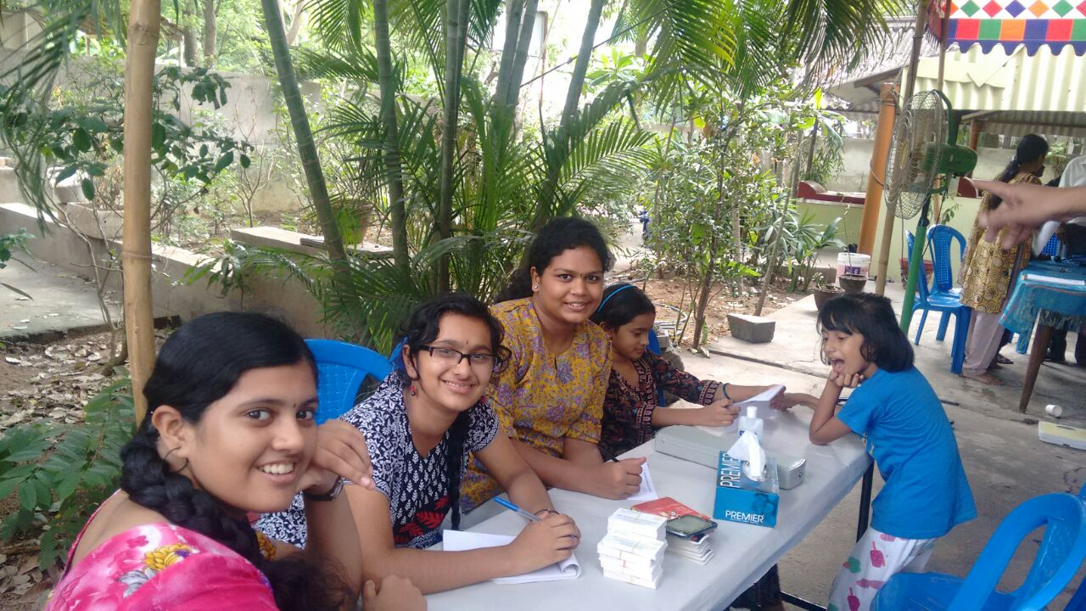

|  |  |
| --- | --- |
| Image result for Rotary ClubImage result for Rotary ClubImage result for Rotary Club**Rotary club of Adyar** | **Interact club installation at DEVI ACADEMY SCHOOL – VALASARVAKKAM**  **CHENNAI** |
| **ON 5TH August 2015** | **Event report** |

This was their 5 th Interact club installation .

The Chief guest for the function was Rtn Krishna kumar who is the Assistant District Director for Youth services .

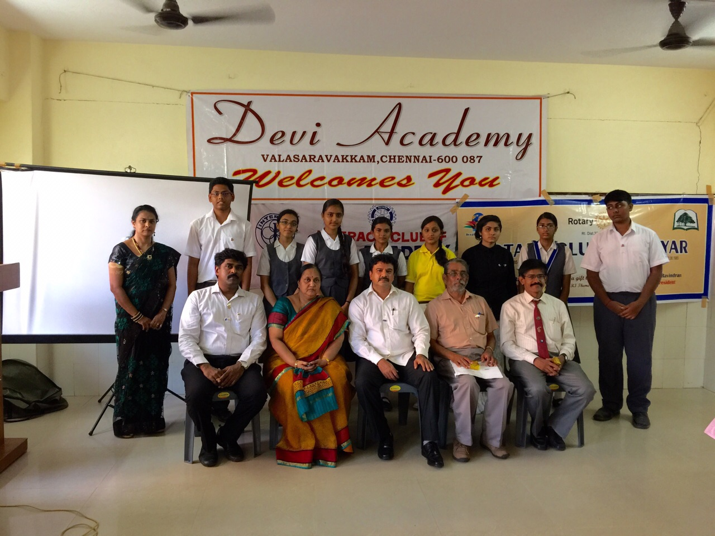

The school correspondent Mdm Rajalekshmi , who was EX ROTARIAN FROM RC ADYAR was the brain behind this interact movement at Devi academy was present .All the installation formalities and procedures were followed.

RtnAnand who is the Director Youth services from RC Adyar , President NR Jayaraman , Secretary RtnEashwer were also present .There was a SKIT on Helen keller’s life story played by the Students of Devi academy which was appreciated by one and all .

The chief guest RtnKrishnakumar , in his speech , appreciated the Scholl management and the Interact club members for their excellent work and keeping up the spirit of Rotary . He explained why and how Rotary movement was started .

Both the out going and incoming office bearers were felicitated . Lapel pins for the Incoming team were pinned. The function got over at 4 pm

|  |  |
| --- | --- |
| Image result for Rotary ClubImage result for Rotary ClubImage result for Rotary Club**Rotary club of Adyar** | **Rotaract club of MNM JAIN ENGINEERING COLLEGE @ THORAIPAKKAM** |
| **13TH Installation on 3rd August 2015 Monday** | **Event report** |

**ROTARACT CLUB OF MNM JAIN ENGINEERING COLLEGE – INSTALLATION CEREMONY**

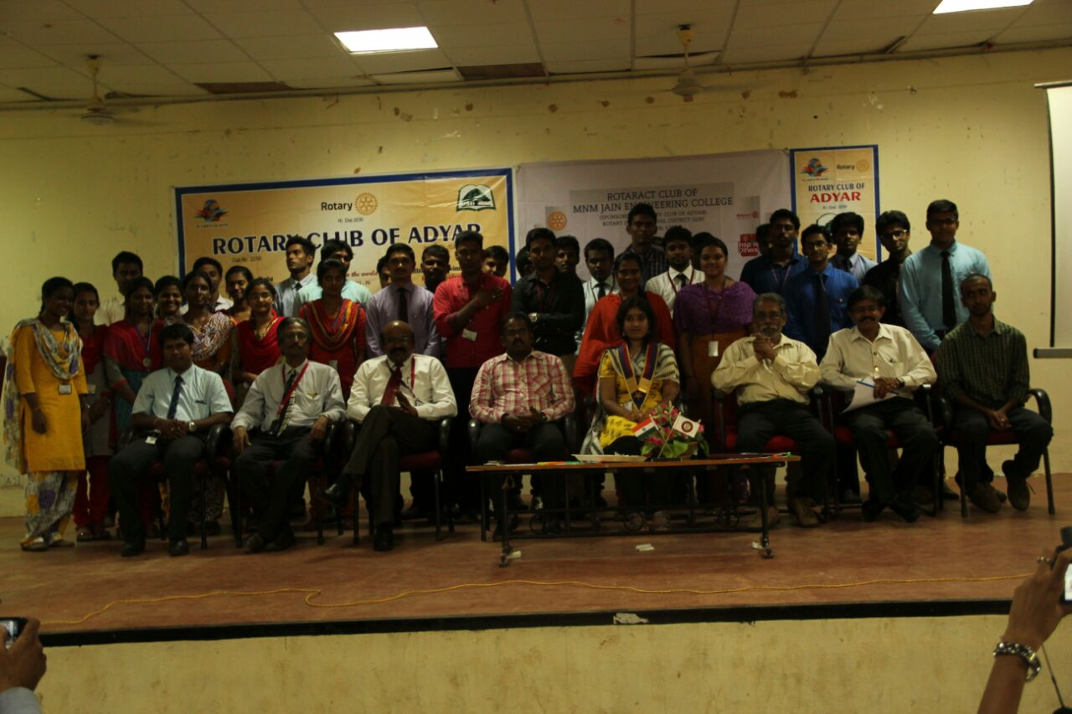

Attended by RtnJayaraman ,RtnEashwer , Ann Swarnalatha

The 13 th Installation of Rotaract club of MNM JAIN ENGINEERING COLLEG THORAI PAKKAM was conducted on 3Rd August 2015 Monday at 230 pm .

The Principal , The Vice principal of the college were present on the Dais , in the function which was held in the College conference hall .The chief Guest for the function was RtnSangaran – District Director for Youth services .

Parent club RC Adyar shared the Lapel Pins and 500 certificates for the members .

The chief Guest explained in detail the growth of Rotary and the role of Rotaract club in the rotary movement . He appreciated the achievements of this MOST ENVIABLE ROTARACT CLUB OF THE DISTRICT . There are 800 Rotaractors in the Club . The Chief Guest and the members on the Dais pinned the Rotaract lapels to the incoming office bearers .

The MNM Rotaract club was adjudged as the BEST ROTARACT CLUB in the district for 2 years and it was appreciated by one and all .

The Principal who has taken charge newly promised all the support to the Club and wished them all the very best .A Detailed presentation on the last year activities was shared by the Secretary of the Club.All the installation formalities were followed and the program ended at 4 pm sharp .

For the first time in 10 years a Lad president was nominated this year ( 2015-16) and She is RtrMs.Sivagami and she took the responsibility and promised her best support to her team for the upcoming year . The incoming secretary is RtrMs.Priya . The outgoing secretary Rtr .Mr.Gowtham proposed the vote of thanks .

**  **

**ROTARY CLUB OF ADYAR**

**(RI DISTRICT 3230 : CLUB NO : 22785)**

**ROTARY YEAR : 2015-2016**

**INVITATION**

**for**

**FIRST BOARD OF DIRECTORS MEETING**

**Dear respected Board members and special invitees ,**

**We have great pleasure in extending this e invite to you for the**

**First Board of Directors meeting for the current Rotary year**

**to be held on 22nd July 2015 Wednesday**

**at NALAS HALL at COSMOPOLITAN CLUB at ANNASALAI .**

**TIMINGS :7.00 PM onwards**

**President Secretary Treasurer**

**N.R.Jayaraman C.Eashwer VijayaPrabhu**

**M-08760151515 M-09500036680 M-09842490258**

